PEOPLE’S COLLEGE OF NURSING & RESEARCH CENTRE, BHOPAL

CONVOCATION

“Your degree is just a tool—Your determination will define your success.”
Our institution takes immense pride in the accomplishments of its nursing graduates and conducts a dignified convocation ceremony to honour their dedication and service. The event marks a significant milestone in the lives of the students, symbolizing their transition from learners to professional nurses.
During the convocation, graduates are formally conferred with their degrees in the presence of distinguished guests, faculty members, and proud families. The ceremony often includes the traditional nursing pledge, reinforcing their commitment to compassionate care, ethical practice, and lifelong learning. Graduates are felicitated with certificates, medals, and tokens of recognition for their academic excellence and clinical proficiency.
The occasion also highlights the values of the nursing profession—service, empathy, and responsibility—while celebrating the perseverance and hard work of the students. It serves not only as a moment of recognition but also as an inspiration for graduates to uphold the dignity of the profession and contribute meaningfully to the healthcare system.
GRADUATION
B.Sc. Nursing
Batch :-2016-2017
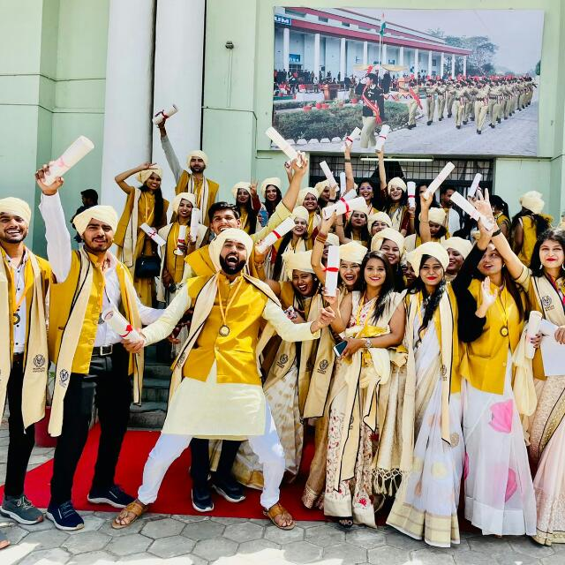
Batch:-2017-2018

Batch:-2018-2019
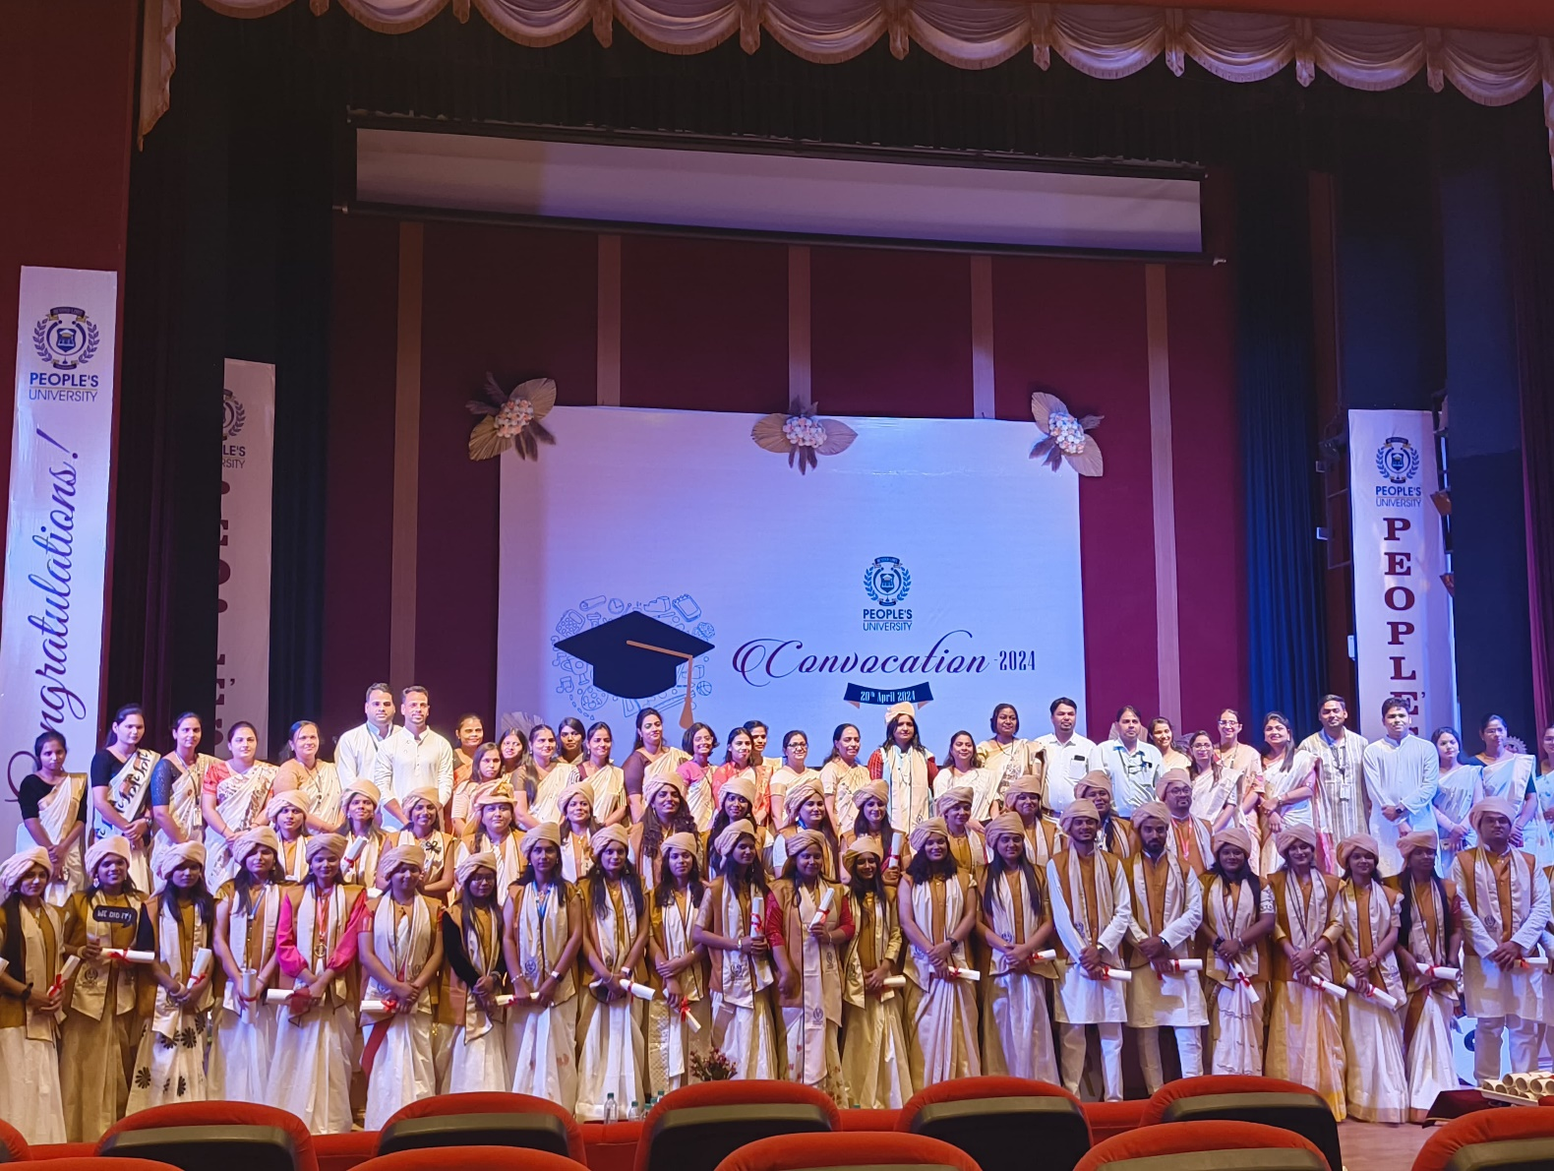

Batch:2019-20
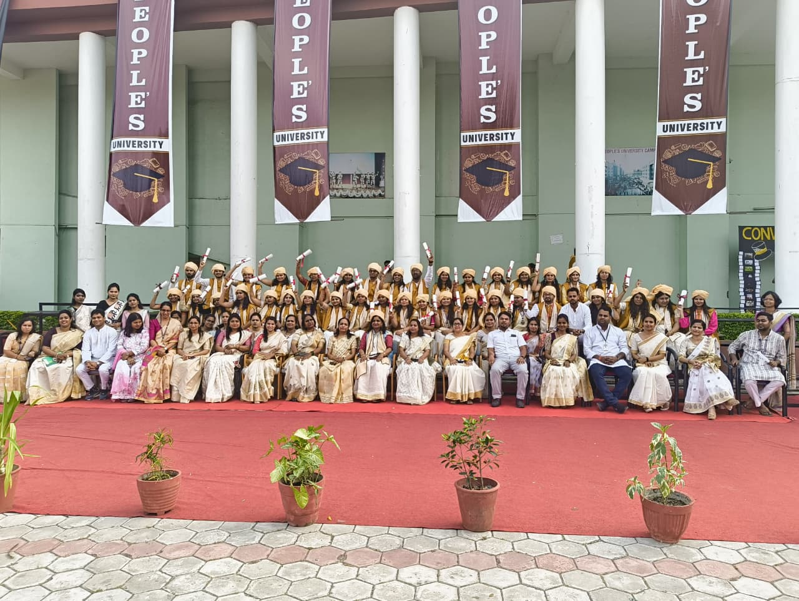
Batch:2020-21

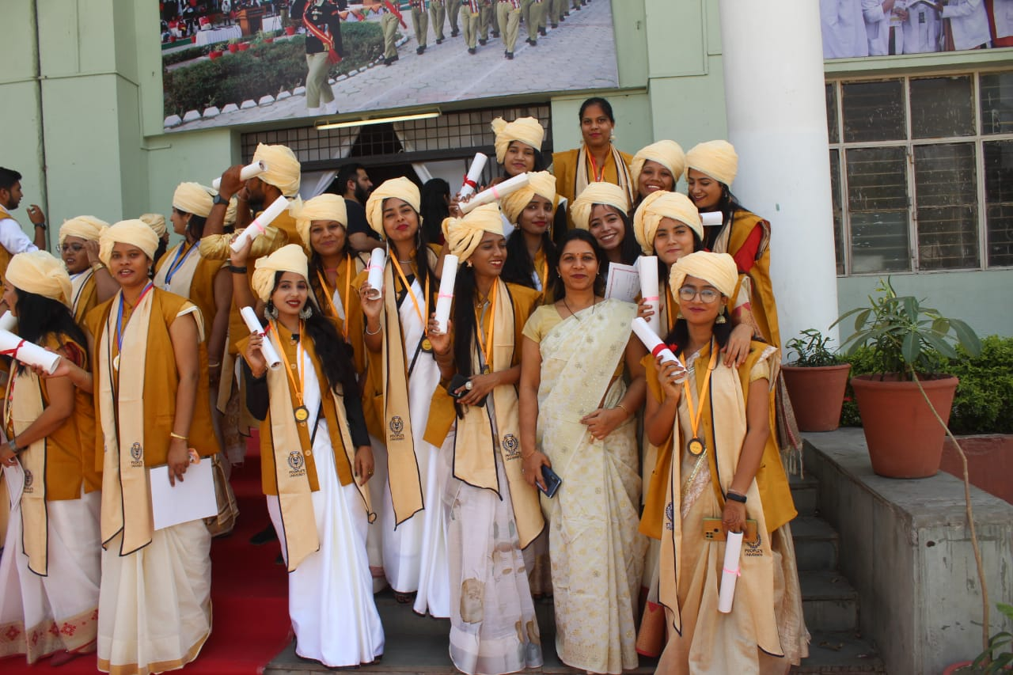

Post Graduation
M.Sc Nursing
Batch:-2021-22




