Criteria – I
1.3.1. Institution integrates crosscutting issues relevant to gender, environment and sustainability, human values, health determinants, right to health issues, emerging demographic changes and professional ethics in the curricula.

List of courses that integrate crosscutting issues

People’s College of Nursing Sciences
COURSES | UNIT | SYLLABUS /ACTIVITIES | COURSE OUTCOME
ENVIRONMENTAL SCIENCES | - Unit 1,2 with sociology community health nursing I  - UNIT (2D) With nutrition  - 2(e) with genetics.  - Unit 3 to 7 community health nursing I & II  and sociology | - Multidisciplinary nature of environmental studies  - Natural resources  - Renewable and non-renewable recourses  - Ecosystems  - Biodiversity and its conservation  - Environmental pollutions  - Social issues and its environment  - Human population and the environment  Field work | Sensitize the students regarding the environmental issues and the role of human beings in managing the environmental hazards.
DISASTER MANAGEMENT | M.sc Nursing Ist year -Advanced nursing practice – unit IX  B.sc nursing III ^{rd} year – medical surgical nursing- unit – VII | - Concepts and principle of disaster nursing  - Causes and types of disaster  - Disaster preparedness  - Team guidelines  - Protocols | Enable the students to manage emergencies and disaster situations.
ENGLISH | - B.Sc Nursing I ^{st} year-60 hours  - P.B.B.sc Ist year -60 Hours | - Review of grammar  - Remedial study of grammar  - Building vocabulary  - Phonetics  - Public speaking  - Read and comprehend prescribed course books  - Various forms of composition  - Spoken English  - Listening comprehension | The course is designed to enable students to enhance ability to comprehend spoken and written English (and use English) required for effective communication in their professional work students will practice their practice their skills in verbal and written during clinical and classroom experiences.
PROFESSIONAL ETHICS | M.Sc Nursing Ist year -Advanced nursing practice – unit I  B.sc nursing I ^{st} year –Nursing Foundation- unit – II | - Code of conduct INC  - Professional conduct  - Ethical principles | Enables the students to practice their profession keeping in mind the ethical principles.
NSS/NCC |  | - Creating awareness in the community regarding very important social issues. | Develops the responsibility towards the country through selfless social services.
SOFT SKILLS | B.Sc nursing IInd year – communication and educational technology- unit – I  M.sc Nursing IInd year - nursing management – unit VI | Communication process ,types ,strategies , interpersonal communication ,channels ,barriers , problems | It develops skill in communicating effectively and maintaining effective interpersonal relations.
People’s Dental Academy
Program | Course | Year/Semester | Category | Description
BDS | Environmental Sciences | I Year | Environment and Sustainability | Study About The Environmental Science (ES) classes had been designed for 1st BDS students to teach them about ecology and the interaction between humans and the natural world. Regular classes are conducted every year to pursue graduate work in diverse areas, ranging from their undergraduate focus to law, public health, or policy. In addition, Environmental Science majors graduate with the necessary skills to join government or non-governmental agencies after completion of their BDS course. More than 50 lecture classes were scheduled and taken by the faculty in 2017-18 as per UGC syllabus and guidelines.
BDS | Disaster Management | Internship | Disaster management | Disaster Management classes had been designed for Internship students to provide a basis knowledge towards preparedness and also helps to develop a culture of safety and prevention. The adoption of a disaster risk reduction perspective in the teaching of the course would be useful. While disasters are generally seen as an outcome of catastrophic natural events, the idea of pre-existing vulnerabilities is equally important. These need to be understood and addressed if disaster impacts are to be minimized. More than 50 lecture classes were scheduled and taken by the faculty in 2017-18 as per UGC syllabus and guidelines

School of Pharmacy and Research

List of  cross-cutting issue | Subject head in curriculum of SOP&R addressing the issues | Integration attempt by the Institution
Gender:  A balanced approach is needed to redress gender inequities in higher education. | BP105T.Communication Skills  BP 201T. Human Anatomy and Physiology-II.  BP801T. Biostatistics and Research Methodology.  BP 812 ET. Dietary Supplements and Nutraceuticals. | Guest lectures
Environment and sustainability:  The college strives to develop environmentally responsible campus. | BP 206 T. Environmental Sciences.  BP 303 T. Pharmaceutical Microbiology.  BP 304 T. Pharmaceutical Engineering.  BP 405T. Pharmacognosy and PhytochemistryI.  BP 505 T. Pharmaceutical Jurisprudence.  BP 603 T. Herbal Drug Technology.  BP 605 T. Pharmaceutical Biotechnology.  BP606T.Pharmaceutical Quality Assurance.  BP 702 T. Industrial Pharmacy II. BP806ET.Quality Control and Standardization ofHerbals.  BP 808 ET. Cell and Molecular biology.  BP810ET. Pharmacological ScreeningMethods. | Field visits, tree plantation, plastic free campus through rally, Go for Green By Car Pulling in campus through rally.
Human values  Good character and good learning are complementary. | BP105T.Communication skills.  BP 505 T. Pharmaceutical Jurisprudence.  BP804 ET: Pharmaceutical RegulatorySciences | Guest Lectures, prevention of ragging through orientation program, constitution day.

Health determinants | BP101T. Human Anatomy  And Physiology-I  BP 201T II.  BP203 T. Biochemistry  BP 204T.  Pathophysiology.  BP 303 T. Pharmaceutical Microbiology  BP 404 T. Pharmacology-I  BP602 T. Pharmacology-III  BP 603 T. Herbal Drug Technology. BP 605 T. Pharmaceutical Biotechnology.  BP 703T. Pharmacy Practice.  BP 802T Social and Preventive Pharmacy.  BP 812 ET. Dietary Supplements  and Nutraceuticals | “Antibiotic Awareness Week “camp in collaboration with: the National Service Scheme (NSS) to create awareness regarding Zika Virus
Include lifestyle, behavioural and socio- economic, cultural conditions, health services, family welfare, nutrition etc.
Right to health  As per the Indian constitution it Is not a fundamental right but delegates responsibility of providing affordable healthcare, imposing of pollution free environment for good health. | BP103T. Pharmaceutics- I.  BP 304 T. Pharmaceutical Engineering  BP602 T. Pharmacology-III  BP 603 T. Herbal Drug Technology. BP 605 T. Pharmaceutical Biotechnology.  BP606 T Pharmaceutical Quality Assurance.  BP 703T. Pharmacy Practice.  BP 802T Social and Preventive Pharmacy.  BP804 ET: Pharmaceutical Regulatory Sciences.  BP 805T: Pharmaco-vigilance.  BP 807 ET. Computer Aided Drug Design  BP810 ET. Pharmacological Screening Methods | Herbal Hand Sanitizer preparation by faculty members of SOP&R, PU.  Herbal Liquid Balm,  Sanitization Chamber to sanitize mobiles , key etc
Emerging demographic issues | BP 206 T. Environmental Sciences. BP 505 T. Pharmaceutical Jurisprudence.  BP801T. Biostatistics and Research Methodology.  BP 802T Social and Preventive Pharmacy.  BP 805T: Pharmaco-vigilance.  BP 807 ET. Computer Aided Drug Design.  BP 812 ET. Dietary Supplements  and Nutraceuticals. | International Literacy Day and poster competitions by students

Professional ethics | BP105T. Communication Skills BP103T. Pharmaceutics- I  BP205 T. Computer Applications in  Pharmacy  BP 502 T. Industrial Pharmacy-I  BP503.T.Pharmacology-II.  BP505 T. Pharmaceutical Jurisprudence.  BP606 T. Pharmaceutical Quality Assurance.  BP 702 T. Industrial Pharmacy II.  BP801T. Biostatistics and Research Methodology.  BP803ET. Pharma Marketing Management.  BP804 ET: Pharmaceutical Regulatory Sciences.  BP 805T: Pharma co-vigilance.  BP 806 ET. Quality Control and Standardization of Herbals.  BP 807 ET. Computer Aided Drug Design  BP810 ET. Pharmacological Screening Methods | Expert guest lecture on CADD, Administration of Pharmacist’s oath to students, teachers on Pharmacist Day. Registration of all graduate pharmacists with state pharmacy council. Screening of research reports for plagiarism.

People’s College of Paramedical Science
Program | Course | Year | Category | Description
BPT,BMLT,DDT,DMLT | Environmental Sciences | I Year | Environment and Sustainability | The course includes study of Environment & Ecology ,Social problems & Environment & Role of mankind in conserving natural Resources .
BPT | Health Proffessional Ethics | IV Year | Professional Ethics | The course incorporates scope of Health Ethics & Professional relationship with patients & collogues , with special emphasis on Quality control ,Healthy lab practices ,Confidentiality ,Best practices & legal rights of patients .
BPT,BMLT,DDT,DMLT | Disaster Management | Final Year | Environment and Sustainability | The course includes study of Disasters & their classification, Approches to Disaster reduction and interrelationship between Disasters & development.
BPT,BMLT,DDT,DMLT | Health Research Etics | Final Year | Professional Ethics | The baneberries get an overview about the Principles of ethics ,Good research practices, Research integrity & Scientific misconduct & Ethical vetting of research
BPT,BMLT,DDT,DMLT | National Service Scheme | III & Final Year | Human Values | The course focuses on the role of Youth in Community Mobilization, Leadership & life competencies ,Maintaining social harmony by basic knowledge of sociological & psychological factors involving youth crime & National integration & Health , Hygiene Promotion .

People Institute of Management & Research
Course name | Course code | Programme | Description
Environment and disaster management | FC-203 | BBA/B.COM/Int. MBA | Environment and Sustainability
Business ethics and CSR | FC-601 | BBA/B.COM/Int. MBA | Professional Ethics
Ethics, CSR & Corporate Governance | CP-210 | MBA | Human Values
Health Care Economics | MHA-103 | MBA(HA) | Health Determinants

People Institute of Hotel Management
Course name | Programme | Description
Environmental Studies | BHMCT | Environment and Sustainability

School of Research & Technology
Course name | Programme | Description
Environmental Sciences | B.Tech | Environment and Sustainability
Disaster Management and Safety | B.Tech | Environment and Sustainability
Professional ethics and Proficiency | B.Tech | Professional Ethics

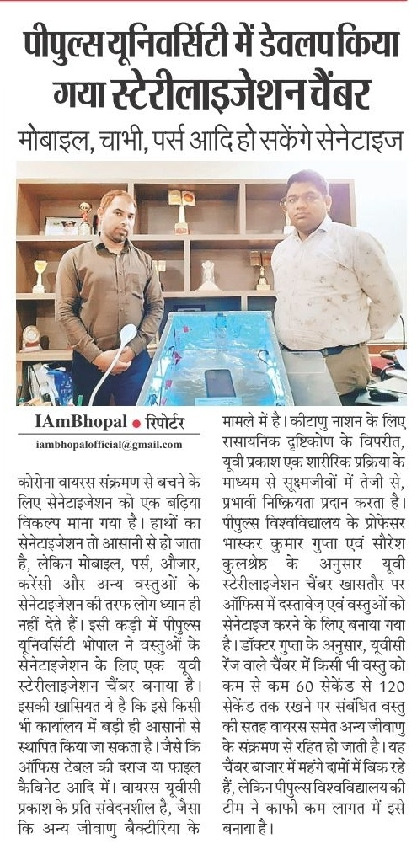
Sanitization Chamber to sanitize mobiles, key etc

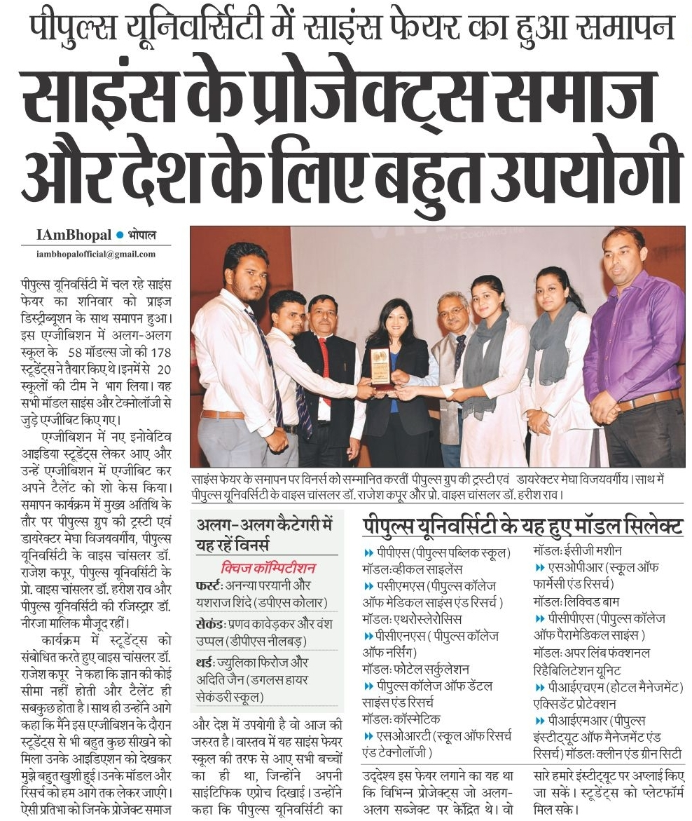
Herbal Liquid Balm

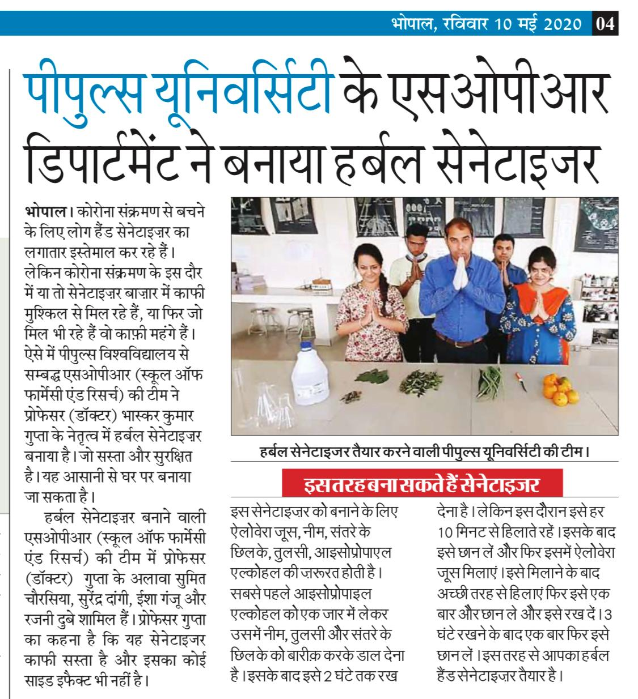

Herbal Hand Sanitizer

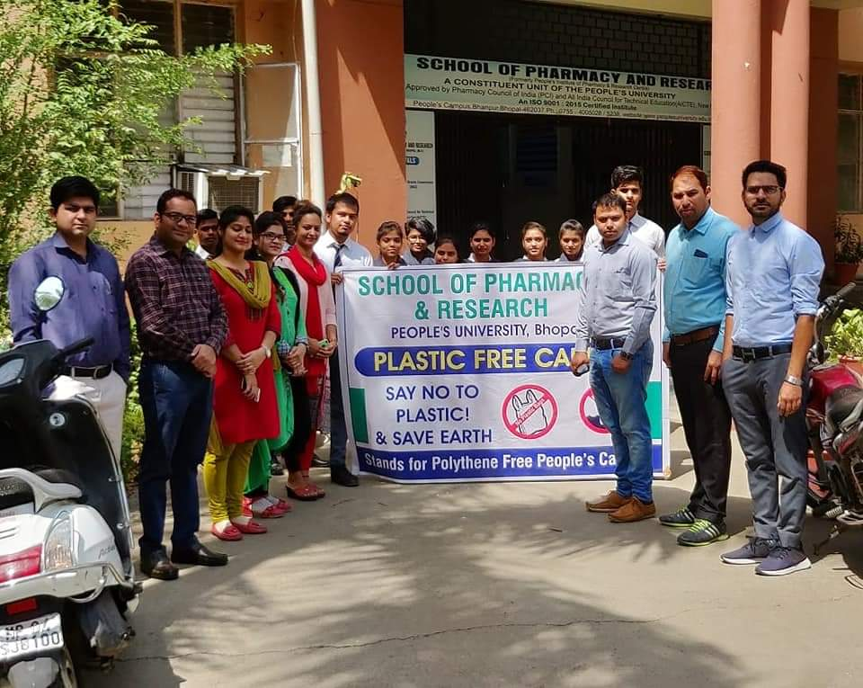

To make Plastic Free Campus

